**Code-First Approach Of Entity Framework In Mvc**

In the code-first approach the Entity Framework creates database objects based on model classes that you create to represent application data.

**THE CODE-FIRST APPROACH:**

* Is the most common approach implemented in ASP.NET MVC Framework.
* Allows you to develop your application by coding model classes and properties and delegate the process of creating the database objects to the Entity Framework.
* The code-first approach allows you to define your own model by creating custom classes.
* Then, you can create database based on the models.

Following figure shows the code-first approach:

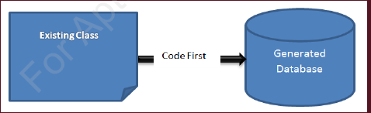

**The DbContext class:**

* Is provided by the System.Data.Entity namespace of the ASP.NET MVC Framework.
* Can be used to define the database context class after creating a model class.
* Coordinates with Entity Framework and allows you to query and save the data in the database.
* Uses the DbSet <T> type to define one or more properties where, T represents the type of an object that needs to be stored in the database.

**Creating Crud Application Using Entity Framework Code First Approach In Asp.Net Mvc**

* C – CREATE --- INSERT DATA INTO DATABASE
* R – READ -- SELECT DATA FROM DATABASE
* U – UPDATE --- UPDATE DATA IN DATABASE
* D – DELETE --- DELETE DATA FROM DATABASE